**Note: The below screenshots shouldn’t be used as a wireframe. This can be used for reference only.**

User clicks Renewal Version History link

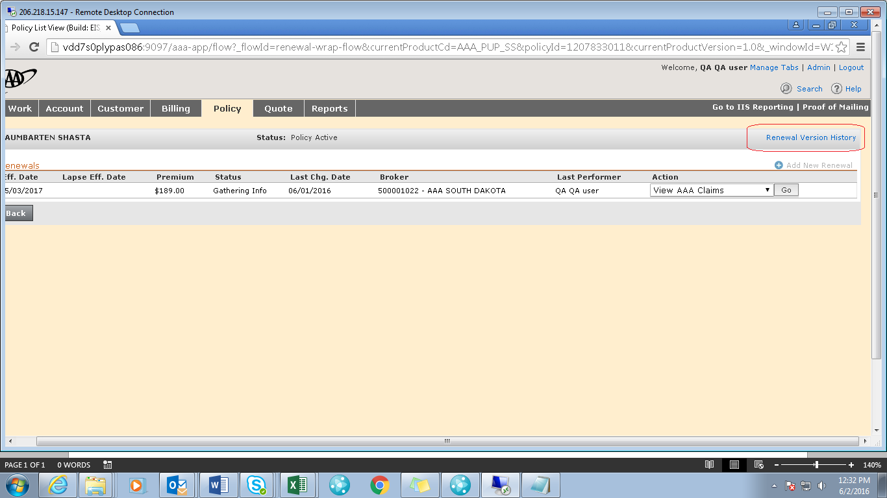

User navigates to Transaction History page

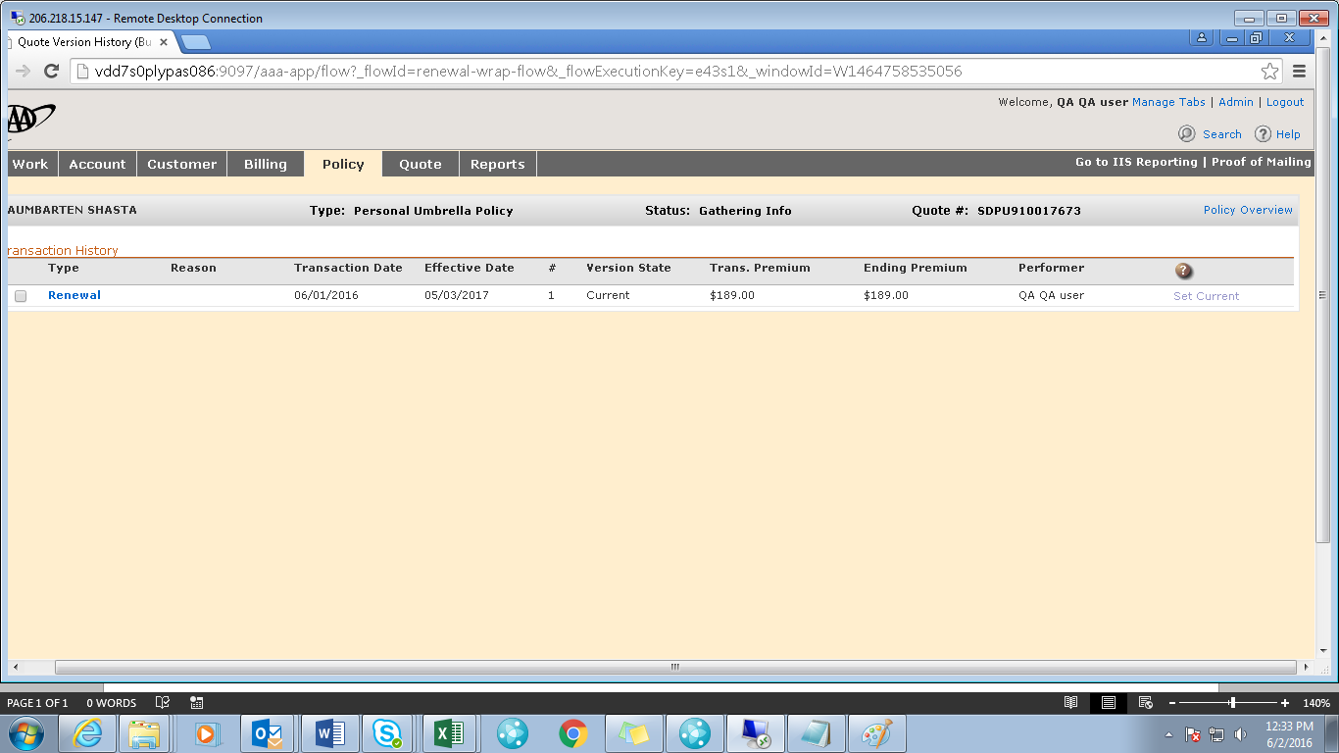

On click of renewal version1 link from Transaction History page, User navigates to Prefill tab in Inquiry mode, ‘Create Version’ is available.

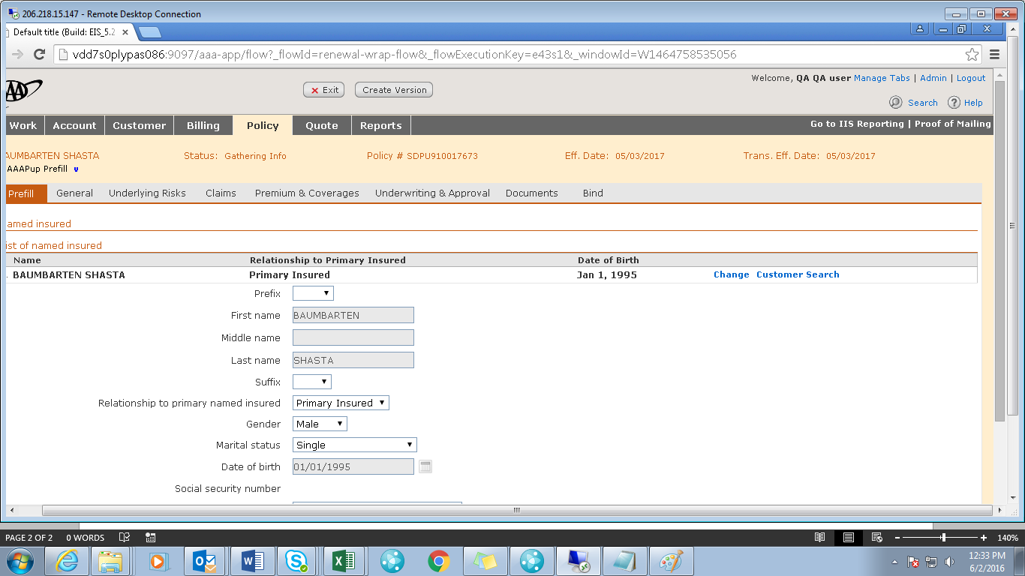

User clicks ‘Create Version’, a pop up shown with description for creating a version.

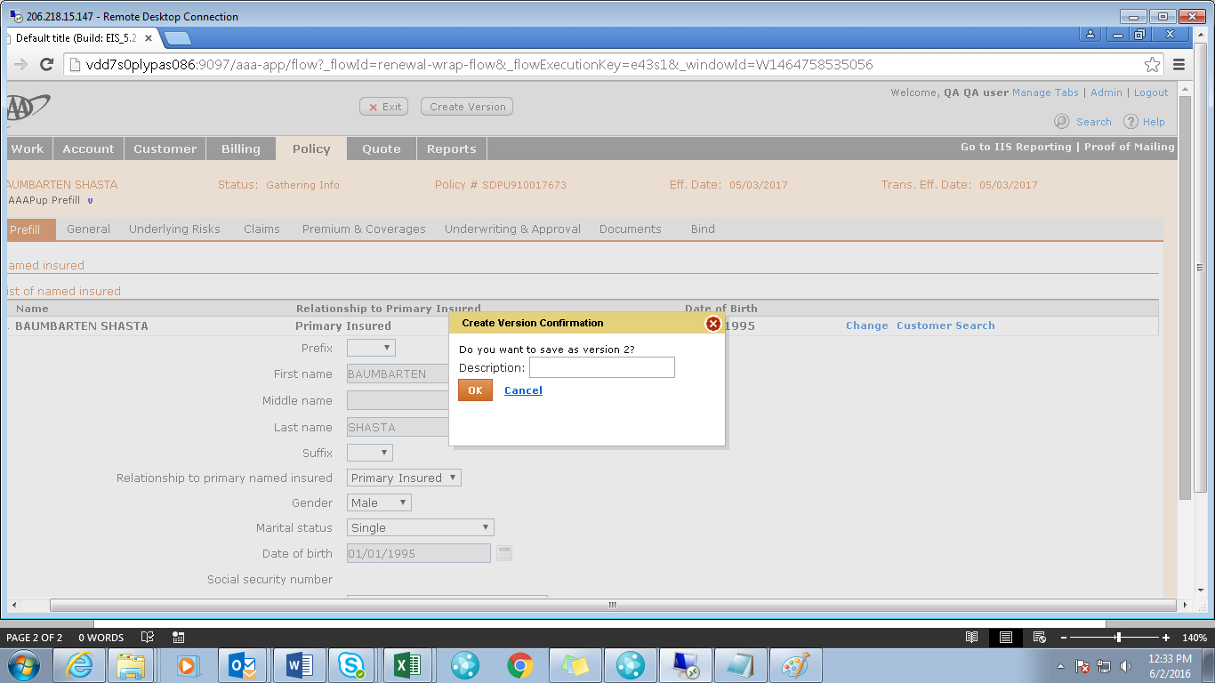

User enters description v2

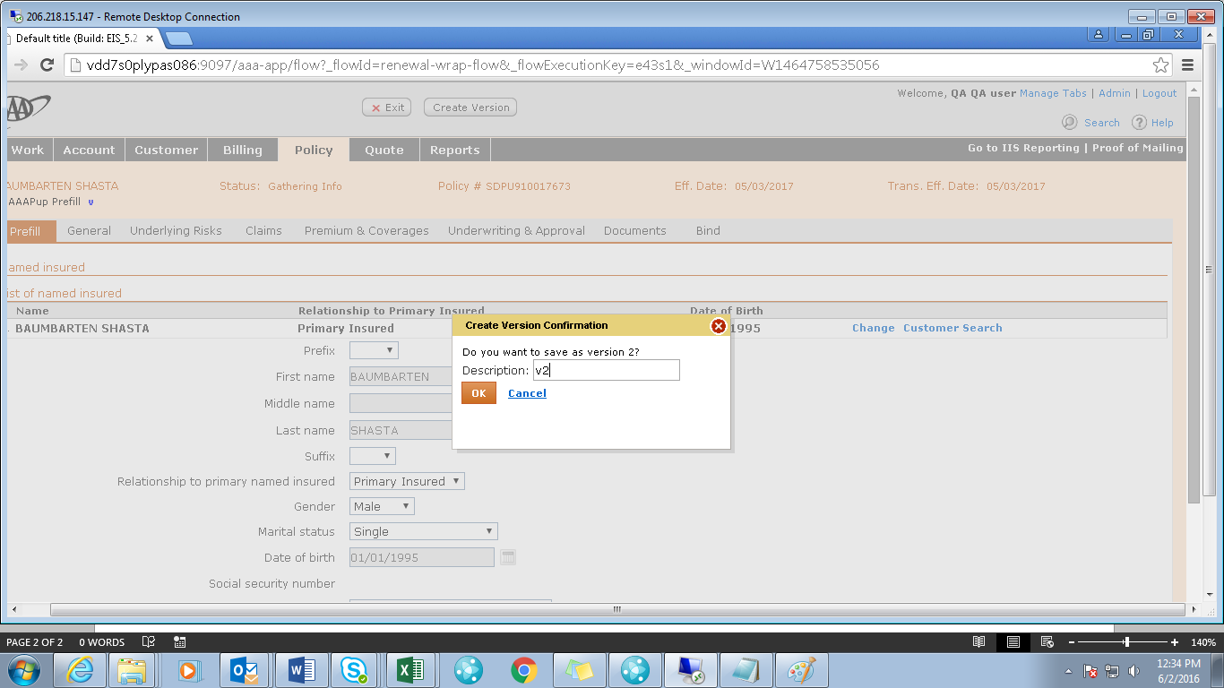

User clicks OK after entered description

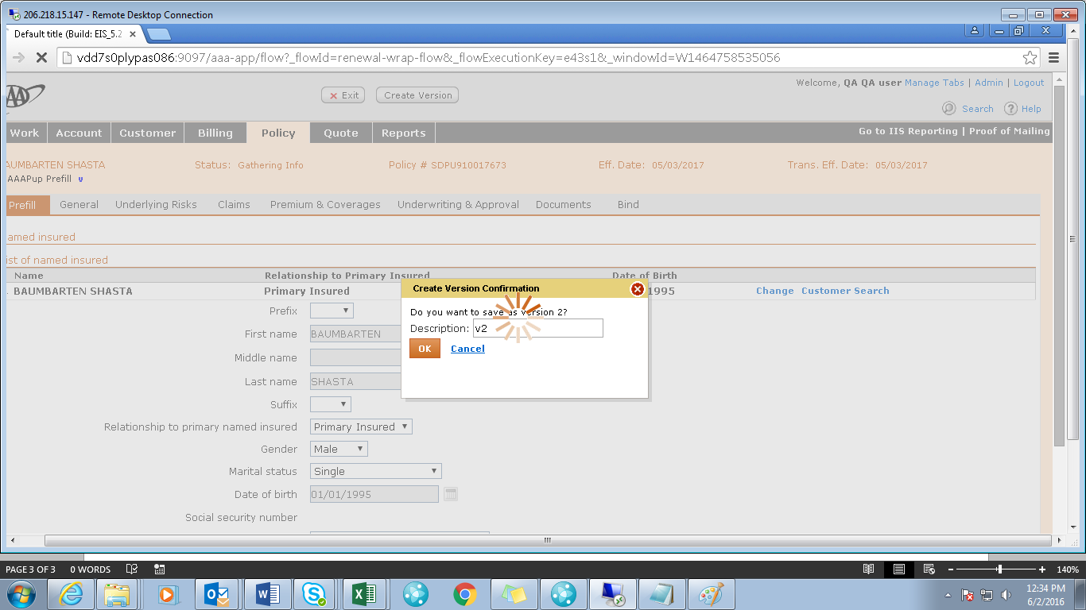

System opens the renewal version2 in Data Gathering

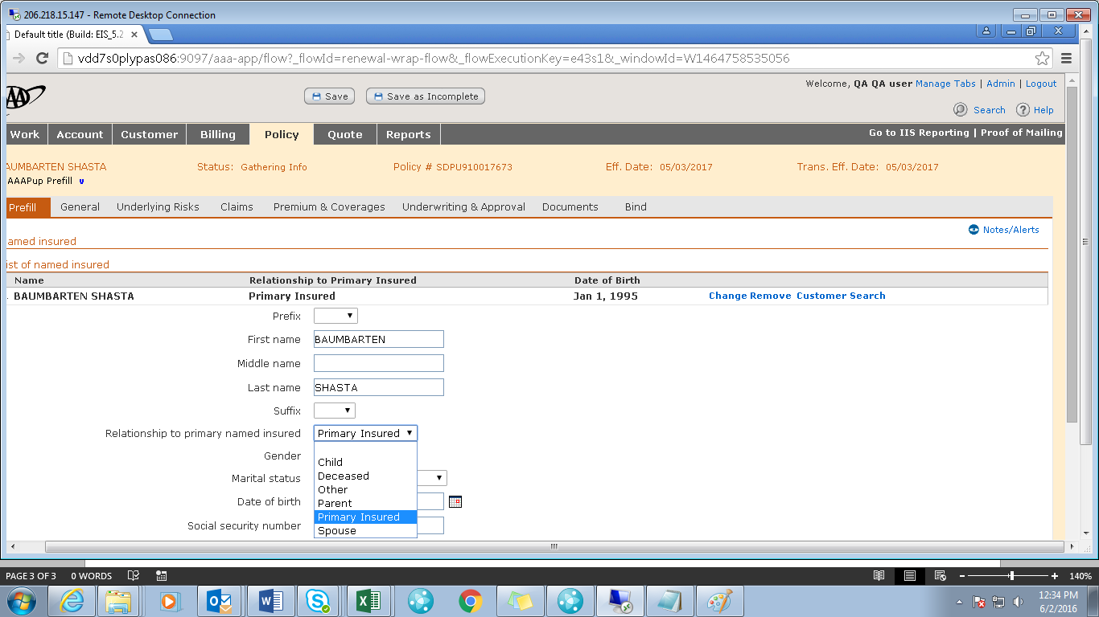

User also can Save as Incomplete before bind the policy.

